Aniya Adil (047)  
  
**FILM BUDGET:**

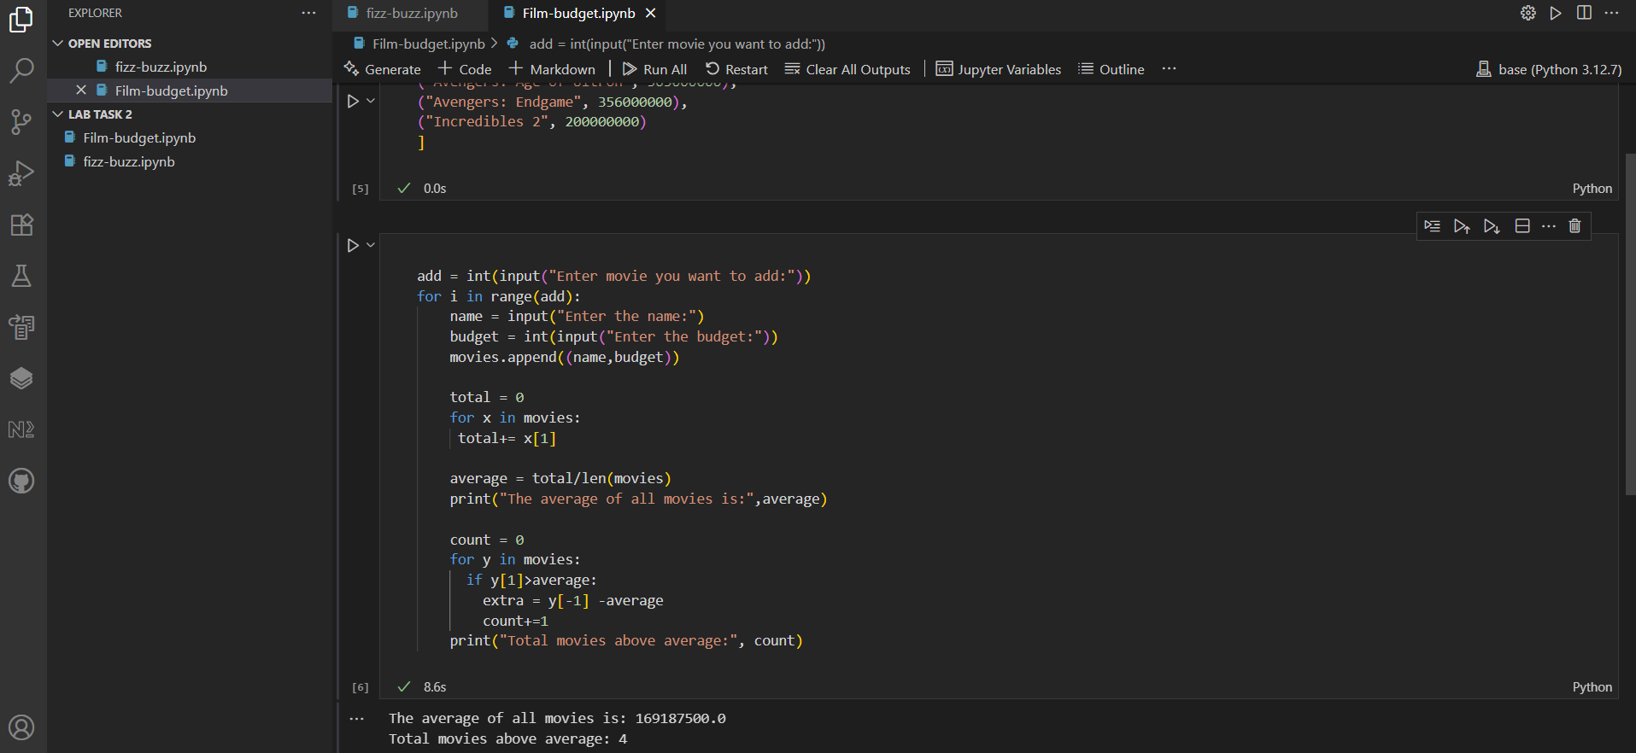

**Step 1: Movie List**

→ The movie name (as a string)  
→ Its budget (as an integer)

**Step 2: Add Movies**

Ask the user how many movies they want to add

Create a loop. In each loop:

* Ask the name
* Ask the budget
* Add it to the list of movies using append.

**Step 3: Total and Average Budget**

add their budget to total

Divide total budget by number of movies to get the average.

Print the average budget

**Step 4: Show High-Budget Movies**

Prepare to print high-budget movies, and initialize a count.

for each movie:

* If its budget is higher than average,
* Calculate how much more it spent
* Print that info
* Increase count

**Step 5: Final Count**

Print how many movies above the average budget.